
Sec 1.3 -Analyzing Numerical Data
Aspect Ratios Name:

- A student sketched some art on an 8.5 inch x 11 inch piece of paper. He wants to resize it to fit an 4 inch x 6 inch frame (as shown below)

original sketch
11”
8.5”

x
4”

6”

reduced sketch size
with frame shown

What percent of the original sketch was still able to be included in the frame?

- A person wants to increase a (5 in. x 7 in.) photo to an (8 in. x 10 in.) but since the aspect ratios are not the same some of the picture will get chopped off.



8”

5”

7”10”
x
original picture
blown-up picture
with frame shown

What percentage of the picture can be used in the (8 in. x 10 in.) frame?

AMDM Student Worksheets Created By Matthew M. Winking at Phoenix High School SECTION 1-3
p.8

45”

- Television sizes are usually described by the length of their diagonal measure. What would be the listed size of the TV shown in the picture?

26”

16x


- A monitor with a screen dimension ratio of 16:9 is playing a video image with a dimension ratio of 4:3 at its fullest size which left a pillar-boxed image. What percent of the screen’s area is occupied by the image?
4y
9x
3y

4x

24y

- A monitor with a screen dimension ratio of 4:3 is playing a video image with a dimension ratio of 24:10 at its fullest size which left a letter-boxed image. What percent of the screen’s area is occupied by the image?
3x
10y

AMDM Student Worksheets Created By Matthew M. Winking at Phoenix High School SECTION 1-3

p.9


- A chalk board’s dimensions have an aspect ratio of 5:3 (i.e. W:H). If the height of the board is 35 inches how wide is the board?
35”
??”

- A person changed the size of the wheels on his motorcycle
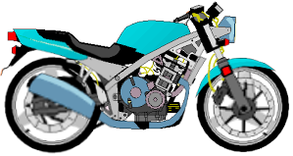
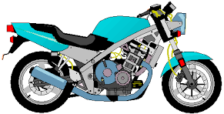

25”
30”

He changed the size from a tire that had a 25 inch diameter to a tire that has a 30 inch diameter. He didn’t realize this would affect his speedometer and odometer. He didn’t recalibrate either after changing the wheel size. How far did he really travel on the new tires, if his odometer shows he traveled 1200 miles?

How fast is he really going on the new tires when his speedometer reads 60 mph?

11. A person decided to alter the appearance of his car by adding a lift kit, new suspension, & larger wheels. The original 1993 Chevrolet Caprice had P225/75R15 tires. The modified version had P305/30R26 tires.
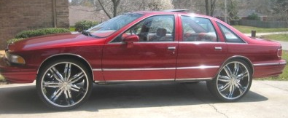
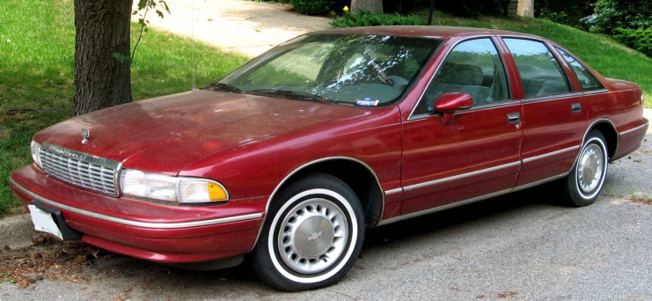

- Determine the diameter of the original tires.
- Determine the diameter of the new tires.

- If the speedometer wasn’t recalibrated, how fast is the person actually going on the new tires when his speedometer shows 60 mph?
AMDM Student Worksheets Created By Matthew M. Winking at Phoenix High School SECTION 1-3

p.10

